Ex. No. 1 | JAVA LOOPS
YouTube Link
Date of Exercise | DD.MM.YYYY

Aim
To understand the fundamental concepts of loops in Java and implement various loop types (for, while, do-while) to control program flow and execute repetitive tasks.

Description
Loops in Java are control flow statements that allow a block of code to be executed repeatedly based on a given condition. They are essential for automating repetitive tasks, iterating over collections of data, and implementing algorithms that require repetitive processing. Java provides three main types of loops: 1. **for Loop**: Used when the number of iterations is known beforehand. It consists of an initialization, a termination condition, and an increment/decrement statement. An enhanced for loop (for-each) is also available for iterating over arrays and collections. 2. **while Loop**: Used when the number of iterations is not known beforehand, and the loop continues as long as a specified boolean condition remains true. The condition is checked before each iteration. 3. **do-while Loop**: Similar to the while loop, but it guarantees that the loop body will execute at least once before the condition is checked. The condition is checked after each iteration. Loops are widely applied in data processing, array and list traversal, implementing search and sort algorithms, and creating interactive programs.

Program
public class JavaLoopsDemo {
public static void main(String[] args) {
System.out.println("--- Demonstrating for loop ---");
// Example 1: Basic for loop to print numbers from 1 to 5
for (int i = 1; i <= 5; i++) {
System.out.println("For Loop Count: " + i);
}
System.out.println("\n--- Demonstrating enhanced for loop ---");
// Example 2: Enhanced for loop (for-each) to iterate over an array
String[] fruits = {"Apple", "Banana", "Cherry"};
for (String fruit : fruits) {
System.out.println("Fruit: " + fruit);
}
System.out.println("\n--- Demonstrating while loop ---");
// Example 3: While loop to sum numbers until sum exceeds 10
int sum = 0;
int num = 1;
while (sum <= 10) {
sum += num;
System.out.println("While Loop: Added " + num + ", Current Sum: " + sum);
num++;
}
System.out.println("\n--- Demonstrating do-while loop ---");
// Example 4: Do-while loop to ensure at least one execution
// (e.g., for menu display or input validation)
int count = 0;
do {
System.out.println("Do-While Loop: Count is " + count);
count++;
} while (count < 3);
}
}

Output Screenshot
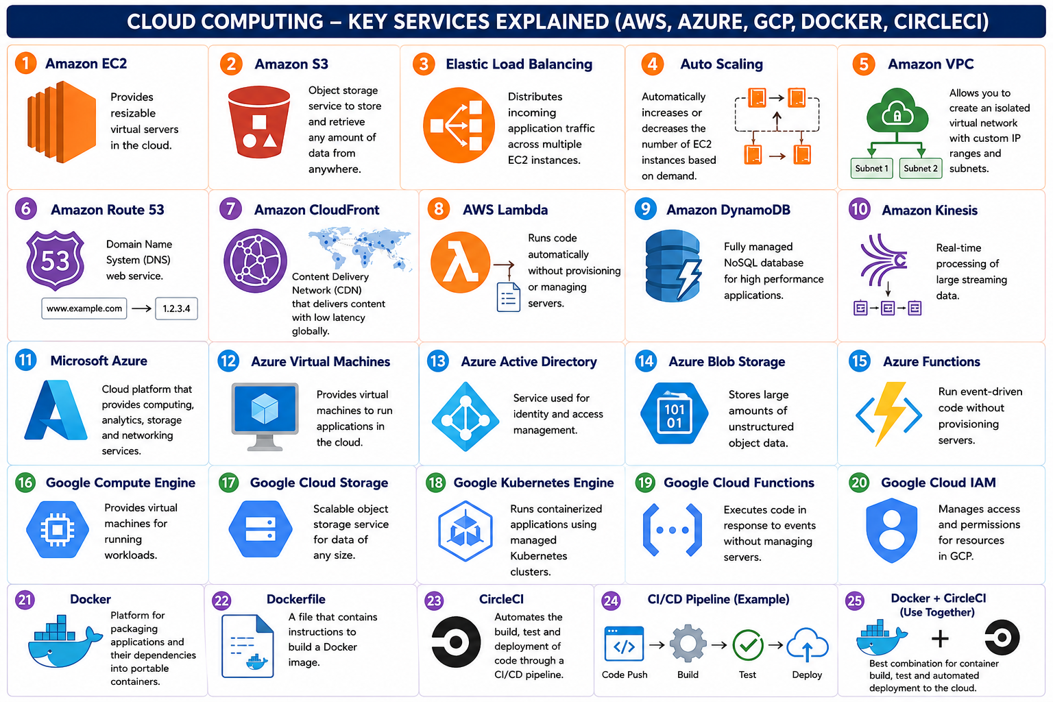

Result
The experiment successfully demonstrated the implementation and functionality of `for`, `while`, and `do-while` loops in Java. Each loop type was shown to effectively control program flow for repetitive tasks, such as counting, array iteration, and conditional execution. The objective of understanding and applying these fundamental control structures for various programming scenarios was successfully achieved.

